AOUT 2021

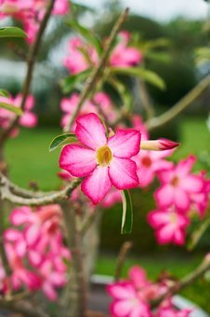

|  |  |  |
| --- | --- | --- |
| *1* | D | Alphonse |
| *2* | L | Julien |
| *3* | M | Lydie |
| *4* | M | J.M.Vianney 31 |
| *5* | J | Abel |
| *6* | V | Transfiguration |
| *7* | S | Gaétan Albert 54 |
| *8* | D | Dominique |
| *9* | L | Amour |
| *10* | M | Laurent |
| 11  Fleur, Nature, Plante, Jardin, Feuille | M | Claire |
| *12* | J | J.F Chantal 32 |
| *13* | V | Hippolyte |
| *14* | S | Evrard |
| *15* | D | Assomption |
| *16* | L | Armel |
| *17* | M | Hyacinthe |
| *18* | M | Hélène |
| *19* | J | Jean Eudes 33 |
| *20* | V | Bernard |
| *21*  Swan, Oiseau, Lac, Cygne Blanc | S | Christophe |
| *22* | D | Fabrice |
| *23* | L | Rose Antoine 28 |
| *24* | M | Barthélemy |
| *25* | M | Louis |
| *26* | J | Natacha 34 |
| *27* | V | Monique |
| *28* | S | Augustin |
| 29 | D | Sabine |
| 30 | L | Fiacre |
| 31 | M | Aristide |

DMJVSD